##### 16. Write a program to implement **StringTokenizer**.

import java.util.StringTokenizer;

import java.util.Scanner;

public class **Test**

{

public static void **main**(String[] args)

{

// Create Scanner object to read input from the user

Scanner scanner = new Scanner(System.in);

// Prompt the user to enter a string

System.out.print("Enter a string to tokenize: ");

// Read the entire line

String input = scanner.nextLine();

// Create StringTokenizer object to split the string by space (" ")

StringTokenizer tokenizer = new StringTokenizer(input);

// Loop through the tokens and print each one

System.out.println("Tokens in the string:");

while (tokenizer.hasMoreTokens())

{

// Get the next token and print it

System.out.println(tokenizer.nextToken());

}

scanner.close();

}

}

**Output:**

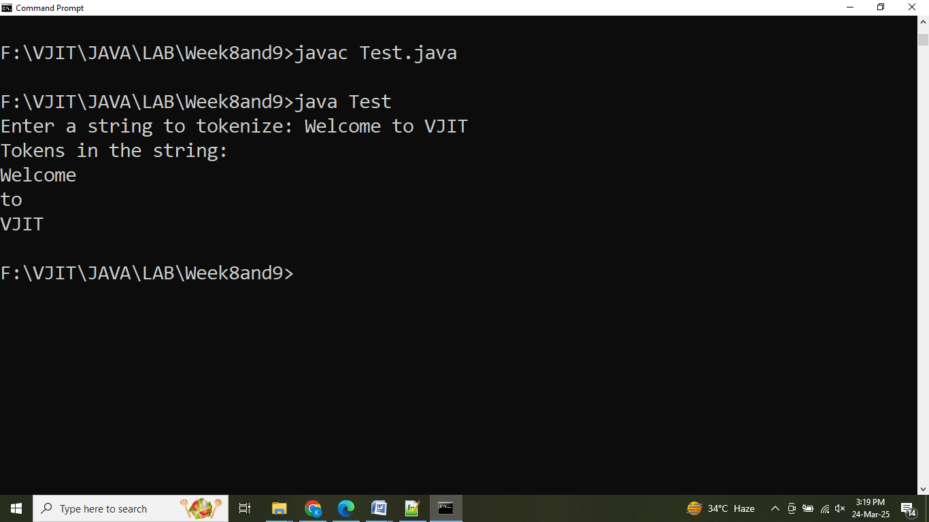

**17. Write a program to read one line at a time, and write it to another file.**

import java.io.*;

import java.util.*;

public class **FileCopy**

{

public static void **copyData**(File source, File destination) throws IOException

{

// Create input and output streams

try (BufferedReader reader = new BufferedReader(new FileReader(source));

BufferedWriter writer = new BufferedWriter(new FileWriter(destination)))

{

String line;

// Read each line from the source file and write it to the destination file

while ((line = reader.readLine()) != null)

{

writer.write(line);

writer.newLine(); // Add a newline after each line

}

System.out.println("Successfully copied contents are:");

}

}

public static void **main**(String[] args) throws Exception

{

Scanner sc = new Scanner(System.in);

System.out.print("Name of source file: ");

String file1 = sc.nextLine();

File s = new File(file1);

System.out.print("Name of destination file: ");

String file2 = sc.nextLine();

File d = new File(file2);

sc.close();

copyData(s, d);

Scanner outFile = new Scanner(new File(file2));

while (outFile.hasNextLine())

{

System.out.println(outFile.nextLine());

}

sc.close();

}

}

**Output:**

